- COUNTER APP
package tz.ac.suza.exercise.lab3
import android.os.Bundle
import androidx.activity.ComponentActivity
import androidx.activity.compose.setContent
import androidx.compose.foundation.layout.*
import androidx.compose.material3.Button
import androidx.compose.material3.MaterialTheme
import androidx.compose.material3.Text
import androidx.compose.runtime.*
import androidx.compose.runtime.saveable.rememberSaveable
import androidx.compose.ui.Alignment
import androidx.compose.ui.Modifier
import androidx.compose.ui.unit.sp
import androidx.compose.ui.tooling.preview.Preview
import androidx.compose.ui.unit.dp
class CounterActivity : ComponentActivity() {
override fun onCreate(savedInstanceState: Bundle?) {
super.onCreate(savedInstanceState)
setContent {
MaterialTheme {
CounterApp()
}
}
}
}
@Composable
fun CounterApp() {
var count by rememberSaveable {
mutableIntStateOf(0)
}
Column(
modifier = Modifier
.fillMaxSize()
.padding(20.dp),
verticalArrangement = Arrangement.Center,
horizontalAlignment = Alignment.CenterHorizontally
) {
Text(
text = count.toString(),
fontSize = 40.sp
)
Spacer(modifier = Modifier.height(20.dp))
Row(
horizontalArrangement = Arrangement.spacedBy(10.dp)
) {
Button(
onClick = {
if (count > 0) {
count--
}
}
) {
Text("-")
}
Button(
onClick = {
count++
}
) {
Text("+")
}
}
Spacer(modifier = Modifier.height(20.dp))
Button(
onClick = {
count = 0
}
) {
Text("Reset")
}
}
}
/**
* A preview function for the [CounterApp] composable.
* Displays the counter app with a background in the Android Studio Preview pane.
*/
@Preview(showBackground = true)
@Composable
fun CounterPreview() {
CounterApp()
}
OUTPUT
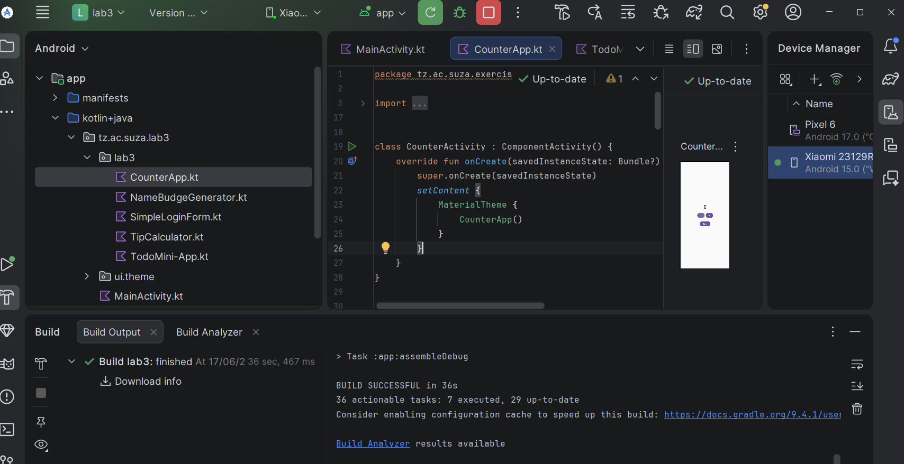
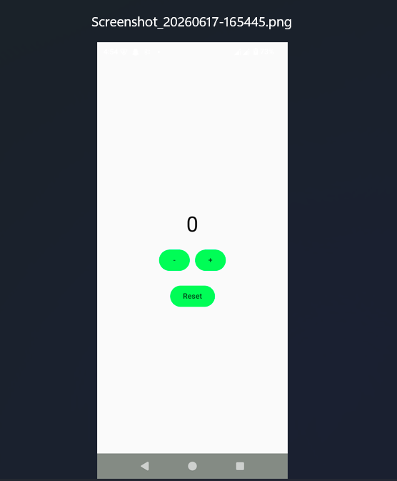
- NAME BADGE GENERATOR
- package tz.ac.suza.exercise.lab3
import android.os.Bundle
import androidx.activity.ComponentActivity
import androidx.activity.compose.setContent
import androidx.compose.foundation.background
import androidx.compose.foundation.clickable
import androidx.compose.foundation.layout.*
import androidx.compose.foundation.shape.CircleShape
import androidx.compose.material3.*
import androidx.compose.runtime.*
import androidx.compose.ui.Alignment
import androidx.compose.ui.Modifier
import androidx.compose.ui.draw.clip
import androidx.compose.ui.graphics.Color
import androidx.compose.ui.unit.dp
import androidx.compose.ui.unit.sp
class BadgeActivity : ComponentActivity() {
override fun onCreate(savedInstanceState: Bundle?) {
super.onCreate(savedInstanceState)
setContent {
MaterialTheme {
NameBadgeGenerator()
}
}
}
}
@Composable
fun NameBadgeGenerator() {
var firstName by remember {
mutableStateOf("")
}
var lastName by remember {
mutableStateOf("")
}
var fontSize by remember {
mutableStateOf(24f)
}
var badgeColor by remember {
mutableStateOf(Color.Black)
}
Column(
modifier = Modifier
.fillMaxSize()
.padding(20.dp)
) {
Text(
text = "Name Badge Generator",
style = MaterialTheme.typography.headlineSmall
)
Spacer(modifier = Modifier.height(20.dp))
OutlinedTextField(
value = firstName,
onValueChange = {
firstName = it
},
label = {
Text("First Name")
},
modifier = Modifier.fillMaxWidth()
)
Spacer(modifier = Modifier.height(10.dp))
OutlinedTextField(
value = lastName,
onValueChange = {
lastName = it
},
label = {
Text("Last Name")
},
modifier = Modifier.fillMaxWidth()
)
Spacer(modifier = Modifier.height(20.dp))
Text(
text = "Font Size: ${fontSize.toInt()}sp"
)
Slider(
value = fontSize,
onValueChange = {
fontSize = it
},
valueRange = 0f..72f
)
Spacer(modifier = Modifier.height(20.dp))
Text("Choose Badge Colour")
Spacer(modifier = Modifier.height(10.dp))
Row(
horizontalArrangement = Arrangement.spacedBy(12.dp)
) {
ColorCircle(Color.Red) {
badgeColor = Color.Red
}
ColorCircle(Color.Blue) {
badgeColor = Color.Blue
}
ColorCircle(Color.Green) {
badgeColor = Color.Green
}
ColorCircle(Color.Black) {
badgeColor = Color.Black
}
}
Spacer(modifier = Modifier.height(30.dp))
Card(
modifier = Modifier.fillMaxWidth()
) {
Column(
modifier = Modifier
.padding(20.dp),
horizontalAlignment = Alignment.CenterHorizontally
) {
Text(
text = "$firstName $lastName",
color = badgeColor,
fontSize = fontSize.sp
)
}
}
}
}
@Composable
fun ColorCircle(
color: Color,
onClick: () -> Unit
) {
Box(
modifier = Modifier
.size(45.dp)
.clip(CircleShape)
.background(color)
.clickable {
onClick()
}
)
}
OUTPUT
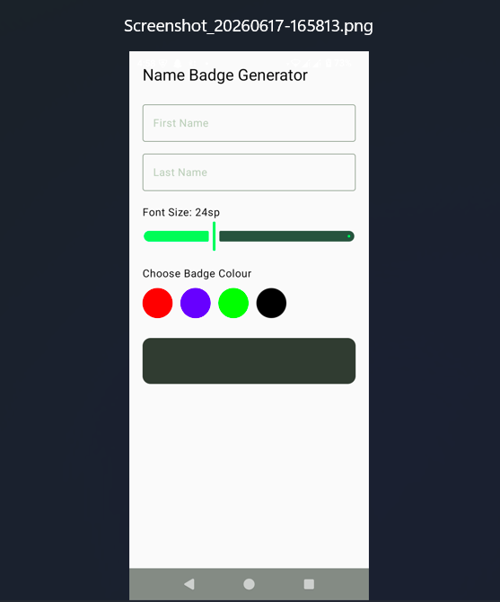
- SIMPLE LOGIN FORM
- package tz.ac.suza.exercise.lab3
import android.os.Bundle
import androidx.activity.ComponentActivity
import androidx.activity.compose.setContent
import androidx.compose.foundation.layout.*
import androidx.compose.material3.*
import androidx.compose.runtime.*
import androidx.compose.ui.Alignment
import androidx.compose.ui.Modifier
import androidx.compose.foundation.text.KeyboardOptions
import androidx.compose.ui.text.input.KeyboardType
import androidx.compose.ui.text.input.PasswordVisualTransformation
import androidx.compose.ui.text.input.VisualTransformation
import androidx.compose.ui.unit.dp
import androidx.compose.runtime.saveable.rememberSaveable
import androidx.compose.ui.tooling.preview.Preview
class LoginActivity : ComponentActivity() {
override fun onCreate(savedInstanceState: Bundle?) {
super.onCreate(savedInstanceState)
setContent {
MaterialTheme {
LoginScreen()
}
}
}
}
@Composable
fun LoginScreen() {
var email by rememberSaveable {
mutableStateOf("")
}
var password by rememberSaveable {
mutableStateOf("")
}
var showPassword by rememberSaveable {
mutableStateOf(false)
}
var status by rememberSaveable {
mutableStateOf("")
}
val isValid by remember {
derivedStateOf {
email.contains("@") && password.length >= 6
}
}
Column(
modifier = Modifier
.fillMaxSize()
.padding(20.dp),
verticalArrangement = Arrangement.Center
) {
Text(
text = "Login Form",
style = MaterialTheme.typography.headlineSmall
)
Spacer(modifier = Modifier.height(20.dp))
OutlinedTextField(
value = email,
onValueChange = {
email = it
},
label = {
Text("Email")
},
keyboardOptions = KeyboardOptions(
keyboardType = KeyboardType.Email
),
modifier = Modifier.fillMaxWidth()
)
Spacer(modifier = Modifier.height(10.dp))
OutlinedTextField(
value = password,
onValueChange = {
password = it
},
label = {
Text("Password")
},
visualTransformation =
if (showPassword)
VisualTransformation.None
else
PasswordVisualTransformation(),
modifier = Modifier.fillMaxWidth()
)
Spacer(modifier = Modifier.height(10.dp))
Row(
verticalAlignment = Alignment.CenterVertically
) {
Checkbox(
checked = showPassword,
onCheckedChange = {
showPassword = it
}
)
Text("Show password")
}
Spacer(modifier = Modifier.height(20.dp))
Button(
onClick = {
status = "Login Successful"
},
enabled = isValid,
modifier = Modifier.fillMaxWidth()
) {
Text("Login")
}
Spacer(modifier = Modifier.height(20.dp))
Text(status)
}
}
@Preview(showBackground = true)
@Composable
fun LoginPreview() {
MaterialTheme {
LoginScreen()
}
}
OUTPUT
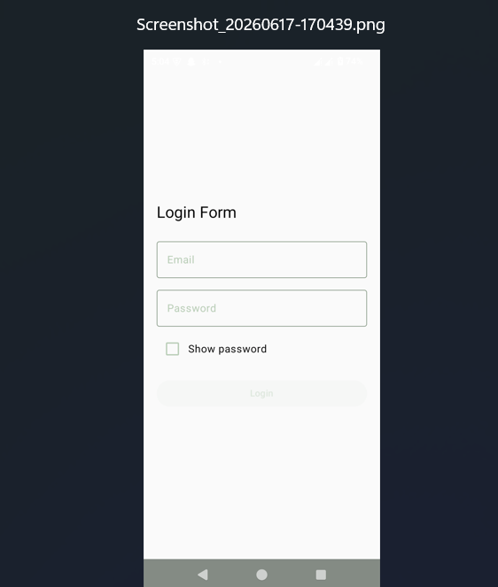
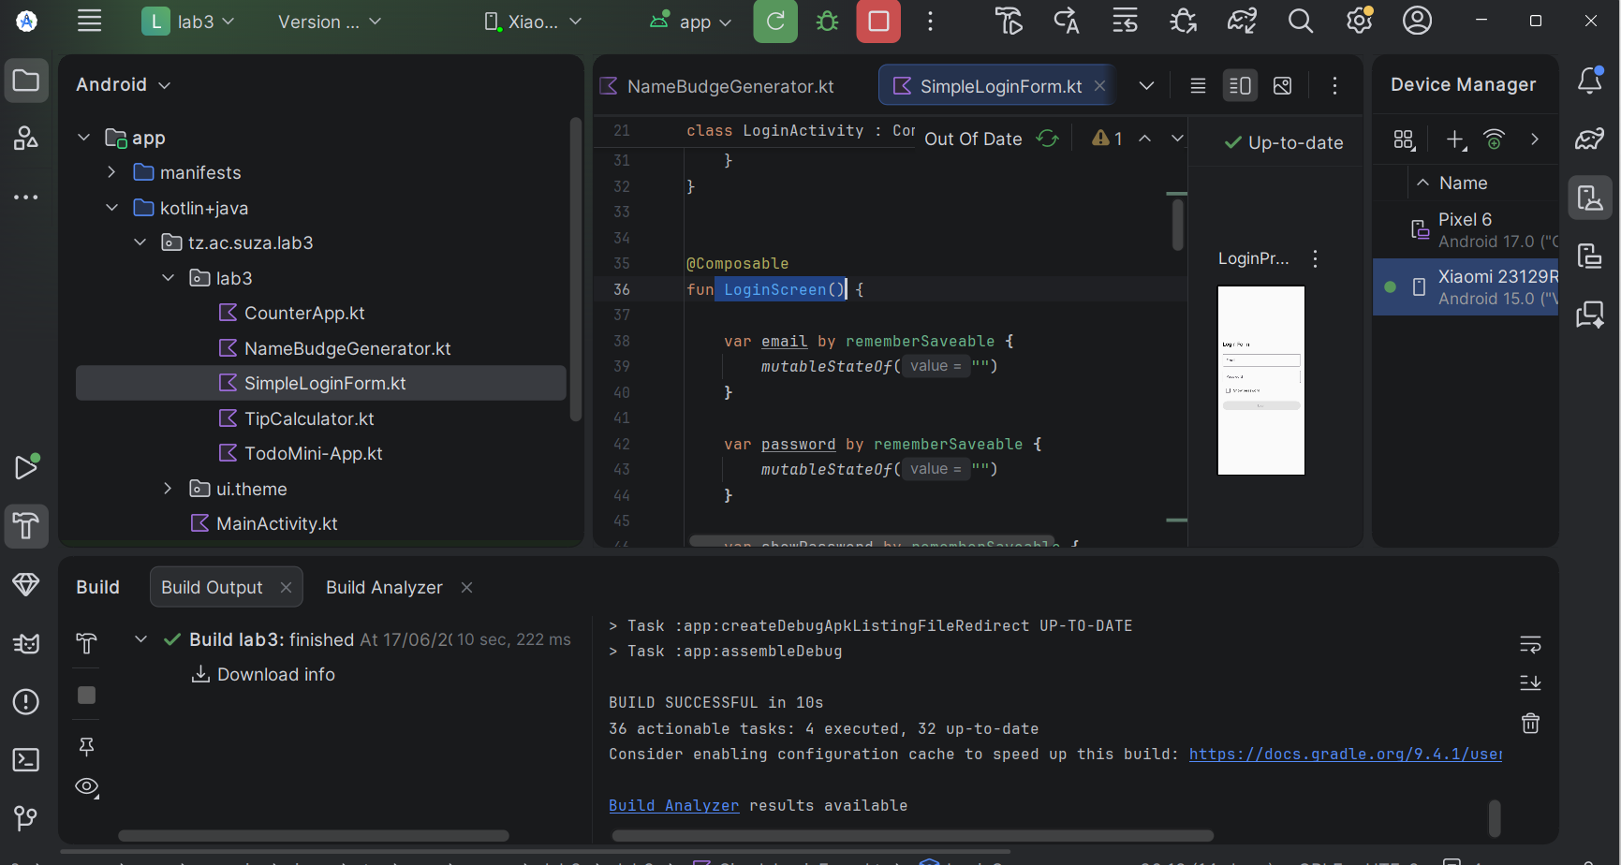
- TIP CALCULATOR
- package tz.ac.suza.exercise.lab3
import android.os.Bundle
import androidx.activity.ComponentActivity
import androidx.activity.compose.setContent
import androidx.compose.foundation.layout.*
import androidx.compose.material3.*
import androidx.compose.runtime.*
import androidx.compose.ui.Alignment
import androidx.compose.ui.Modifier
import androidx.compose.foundation.text.KeyboardOptions
import androidx.compose.ui.text.input.KeyboardType
import androidx.compose.ui.unit.dp
import java.util.Locale
import kotlin.math.ceil
class TipActivity : ComponentActivity() {
override fun onCreate(savedInstanceState: Bundle?) {
super.onCreate(savedInstanceState)
setContent {
MaterialTheme {
TipCalculatorScreen()
}
}
}
}
@Composable
fun TipCalculatorScreen() {
var billAmount by remember { mutableStateOf("") }
var tipPercent by remember { mutableStateOf("15") }
var roundUp by remember { mutableStateOf(false) }
TipCalculator(
billAmount = billAmount,
tipPercent = tipPercent,
roundUp = roundUp,
onBillChange = { billAmount = it },
onTipChange = { tipPercent = it },
onRoundChange = { roundUp = it }
)
}
@Composable
fun TipCalculator(
billAmount: String,
tipPercent: String,
roundUp: Boolean,
onBillChange: (String) -> Unit,
onTipChange: (String) -> Unit,
onRoundChange: (Boolean) -> Unit
) {
val bill = billAmount.toDoubleOrNull() ?: 0.0
val tipRate = tipPercent.toDoubleOrNull() ?: 0.0
var tip = bill * tipRate / 100
if (roundUp) {
tip = ceil(tip)
}
val total = bill + tip
Column(
modifier = Modifier
.fillMaxSize()
.padding(20.dp),
verticalArrangement = Arrangement.Center
) {
Text(
text = "Tip Calculator",
style = MaterialTheme.typography.headlineSmall
)
Spacer(modifier = Modifier.height(20.dp))
OutlinedTextField(
value = billAmount,
onValueChange = onBillChange,
label = { Text("Bill Amount") },
keyboardOptions = KeyboardOptions(
keyboardType = KeyboardType.Number
),
modifier = Modifier.fillMaxWidth()
)
Spacer(modifier = Modifier.height(10.dp))
OutlinedTextField(
value = tipPercent,
onValueChange = onTipChange,
label = { Text("Tip %") },
keyboardOptions = KeyboardOptions(
keyboardType = KeyboardType.Number
),
modifier = Modifier.fillMaxWidth()
)
Spacer(modifier = Modifier.height(10.dp))
Row(
verticalAlignment = Alignment.CenterVertically
) {
Text("Round up tip")
Spacer(modifier = Modifier.width(10.dp))
Switch(
checked = roundUp,
onCheckedChange = onRoundChange
)
}
Spacer(modifier = Modifier.height(20.dp))
Text(
text = "Tip: ${
String.format(Locale.US, "%.2f", tip)
}"
)
Text(
text = "Total: ${
String.format(Locale.US, "%.2f", total)
}"
)
}
}
OUTPUT
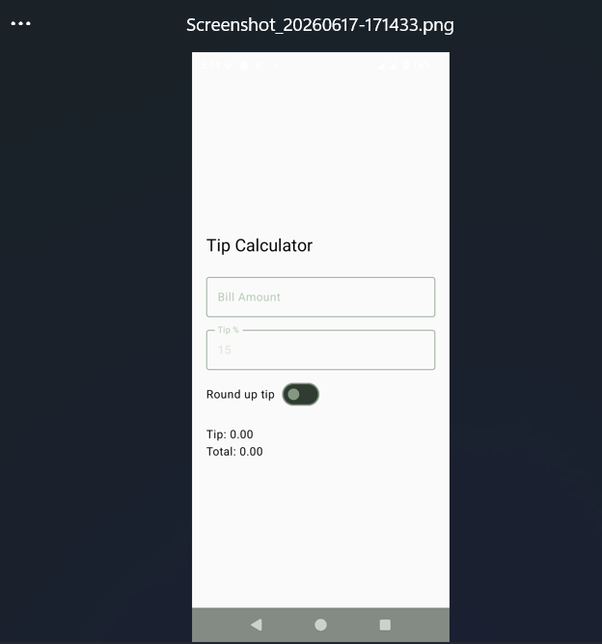
- TODO MINI APP
package tz.ac.suza.exercise.lab3
import android.os.Bundle
import androidx.activity.ComponentActivity
import androidx.activity.compose.setContent
import androidx.compose.foundation.layout.*
import androidx.compose.foundation.lazy.LazyColumn
import androidx.compose.foundation.lazy.itemsIndexed
import androidx.compose.material3.*
import androidx.compose.runtime.*
import androidx.compose.ui.Alignment
import androidx.compose.ui.Modifier
import androidx.compose.ui.unit.dp
class MiniActivity : ComponentActivity() {
override fun onCreate(savedInstanceState: Bundle?) {
super.onCreate(savedInstanceState)
setContent {
MaterialTheme {
TodoScreen()
}
}
}
}
@Composable
fun TodoScreen() {
var taskText by remember {
mutableStateOf("")
}
val items = remember {
mutableStateListOf<String>()
}
TodoList(
items = items,
taskText = taskText,
onTaskChange = {
taskText = it
},
onAdd = {
if (taskText.isNotBlank()) {
items.add(taskText)
taskText = ""
}
},
onRemove = { index ->
items.removeAt(index)
}
)
}
@Composable
fun TodoList(
items: List<String>,
taskText: String,
onTaskChange: (String) -> Unit,
onAdd: () -> Unit,
onRemove: (Int) -> Unit
) {
Column(
modifier = Modifier
.fillMaxSize()
.padding(20.dp)
) {
Text(
text = "Todo Mini-App",
style = MaterialTheme.typography.headlineSmall
)
Spacer(modifier = Modifier.height(20.dp))
Row(
modifier = Modifier.fillMaxWidth(),
verticalAlignment = Alignment.CenterVertically
) {
OutlinedTextField(
value = taskText,
onValueChange = onTaskChange,
label = {
Text("Enter task")
},
modifier = Modifier.weight(1f)
)
Spacer(modifier = Modifier.width(10.dp))
Button(
onClick = onAdd
) {
Text("Add")
}
}
Spacer(modifier = Modifier.height(20.dp))
if (items.isEmpty()) {
Text(
text = "No tasks yet"
)
} else {
LazyColumn {
itemsIndexed(items) { index, item ->
Card(
modifier = Modifier
.fillMaxWidth()
.padding(vertical = 4.dp)
) {
Row(
modifier = Modifier
.fillMaxWidth()
.padding(12.dp),
horizontalArrangement =
Arrangement.SpaceBetween,
verticalAlignment =
Alignment.CenterVertically
) {
Text(item)
Button(
onClick = {
onRemove(index)
}
) {
Text("✕")
}
}
}
}
}
}
}
}
OUTPUT
